SARDAR VALLABHBHAI NATIONAL INSTITUTE OF TECHNOLOGY, SURAT
DEPARTMENT OF CIVIL ENGINEERING
GEOTECHNICAL ENGINEERING SECTION
ROCK MECHANICS LABORATORY
The Rock Mechanics Laboratory (RML) was established in the year 2022. The laboratory is located at CB1 in the Department of Civil Engineering (Old AMD Block). The Rock Mechanics Laboratory (RML) undertakes research on the properties and behaviour of rocks and geomaterials at near-surface to shallow crustal depth for georesources (energy; storage), and geoengineering (tunnelling). The facilities available in the laboratory are intend to train the students in the field of testing of rocks to determine their physical, index and engineering properties. The Rock Mechanics Laboratory is well-equipped with testing equipment for evaluating all engineering properties of rocks, including index properties, physical properties, strength properties and creep properties. The equipment ranges from the most fundamental to the most sophisticated and is used in PG teaching and research. The research scholars also utilize it for the research and development activities. The existing equipment are also used for generating revenue through consultancy work. List of equipment available in the laboratory is given below:
S. No. | Equipment Name
 | Slake Durability Apparatus
 | Point and Brazilian Test Apparatus
 | Core Drilling Machine
 | Core Cutting and Grinding Machine
 | High Pressure Triaxial Cell
 | Creep Testing Machine

Information Regarding Few Important Set Ups in the Rock Mechanics Laboratory
Slake Durability Apparatus: -
Mortar capable of rotating four drums at 20 rev/min, two test drums of brass wire mesh with one end closed and having a removable cover at another end
USE: Measures the resistance of a rock sample to weakening and disintegration resulting from a standard cycle of drying and wetting.
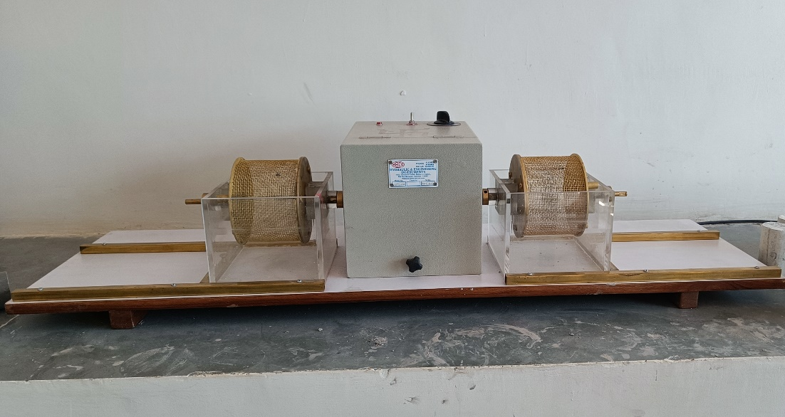
Figure 1 Slake Durability Apparatus

Point and Brazilian Test Apparatus: -
Capacity: - 200kN, all size rock samples.
USE: To determine the tensile strength of brittle materials and rock strength index
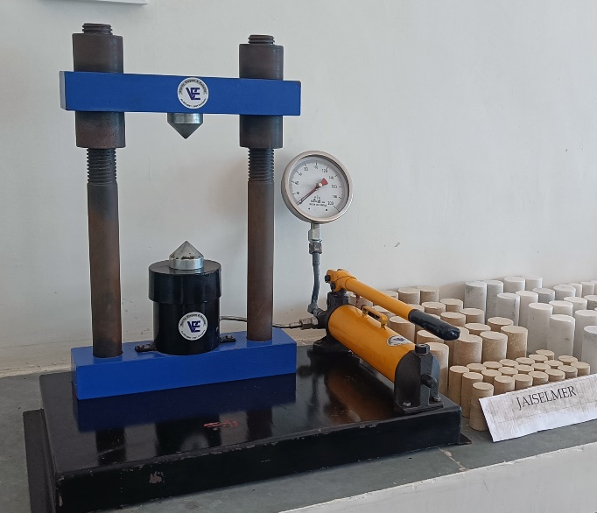
Figure 2 Point and Brazilian Test Apparatus
Core Drilling Machine: -
Core length up to 450 mm, Core Diameter- 38 and 54 mm, Operating speed 450 RPM, Movable frame, Supplier – ASEW
USE: Coring of rock samples in laboratory and field for the physical and mechanical testing

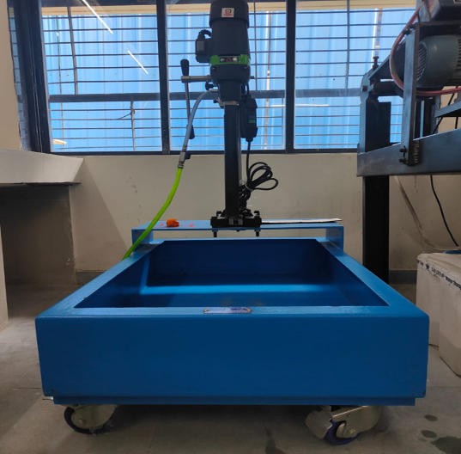
Figure 3 Core Drilling Machine

Core Cutting and Grinding Machine: -
Suitable for Core Diameter- 38, 54, 76, and 100 mm.
USE: Cutting and grinding of cylindrical rock specimens up to 150mm size.
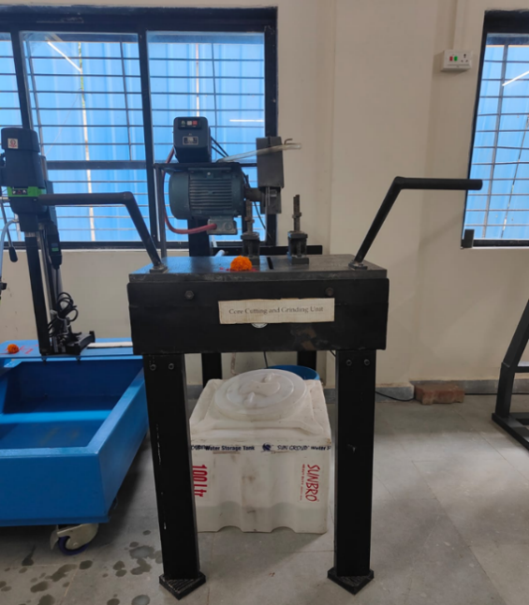
Figure 4 Core Cutting and Grinding Machine
High Pressure Triaxial Cell: -
USE: The cells are designed for testing the rock core samples (e.g., Granites, evaporates, cemented tills or Clays) under triaxial stress conditions. Capacity 20 MPa
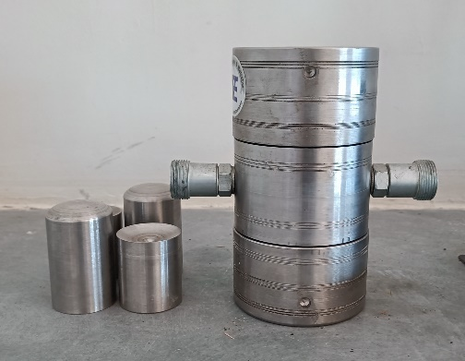
Figure 5 High Pressure Triaxial Cell
Long Term Creep Testing Machine: -
Loading Frame Capacity: - 300 kN, Vertical Testing Space: 500 mm, Proving Ring: 100 kN, Least Count: 1 kN, Mechanical Dial Gauge for Displacement measurement.
USE: Determines the deformation of the rock mass with respect to time under constant stress conditions for longer duration of time and rheological properties of the rock mass
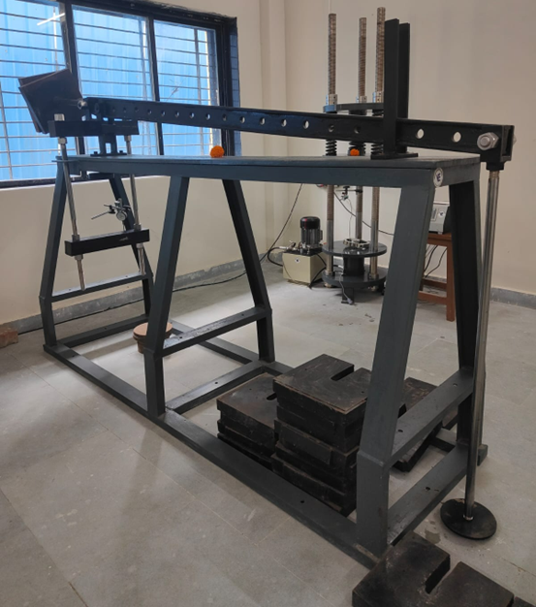
Figure 6 Long Term Creep Testing Machine
Short Term Creep Testing Machine: -
Loading Frame Capacity: - 500 kN, Loading Sensor Capacity: - 200 kN, Vertical Testing Space: 700 mm, Hydraulic Jack: 500 kN, Least Count: 1 kN, Displacement measurement sensor, Digital Data Logger (4 channels).
USE: Determines the deformation of the rock mass with respect to time under constant stress conditions for shorter duration of time and rheological properties of the rock mass
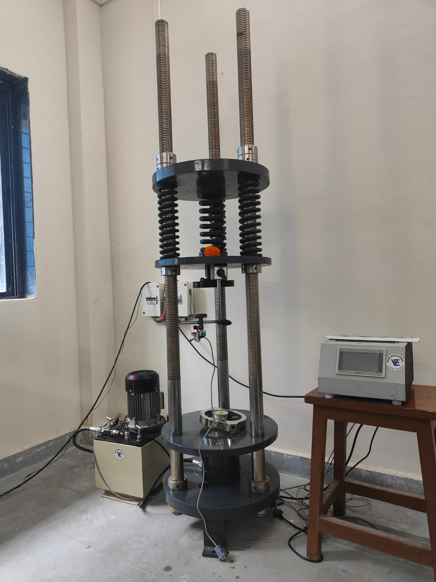
Figure 7 Short Term Creep Testing Machine

LIST OF EXPERIMENTS
Geotechnical Engineering Laboratory-1 (CEGT104) (M. Tech-I (Civil), Semester I)
Sr. No. | Title of Experiment
1 | Compression test
2 | Point load test
3 | Brazilian test
4 | Slack durability test
5 | Short term Creep test
6 | Long term Creep test

